Commons Adoption Application

Applicant Information: (please keep us informed of any changes during your adoption term)
Name: | Phone:
Street: | Email:
City, State, Zip: | Adopted Item Inventory # and details (admin use):
Please complete the attached form to indicate the wording you would like on your dedication plaque.
A proof of the plaque layout will be emailed to you prior to its completion.
Donors will be recognized by name via ID Tag, Plaque, Electronic Newsletter, and via other forms of communication. You may choose to keep your name private by checking this box:

Adoption Preference:
Please note that the adoption term for a tree is 20 years; for benches & picnic tables it is 10 years

- New Tree - $3,000
- Historic Tree - $3,000

- Picnic Table - $2,700
- Park Bench – New: $2,500
(limited availability)
- Park Bench – Refurbished: $1,500 (limited availability)

Payment Options (Choose 1):

- Option 1: Lump sum payment

- Option 2: 3 equal installments of $1,000 (tree adoptions only)

I have read the attached Donation Policy provisions and agree to abide by the terms and limitations. I also understand that donations in excess of program costs will care for park furniture and landscape.

Signature of Donor ____________________________________ Date: __________________
I am including a check in the amount of $___________________________________

Please return completed form along with your donation (or installment) to:
Community for The Commons, 441 Second Street, Excelsior, MN 55331
The Commons Adoption Programs are offered by the City of Excelsior and administered by Community for The Commons, a 501 (c)(3) nonprofit park conservancy. Donations are tax-deductible to the fullest extent of the law. Contact us at Adoptions@communityforthecommons.org or 952-250-4670.

Adoption Program Policy Provisions, City of Excelsior

- Term
The term of adoption for seating is 10 years and for trees is 20 years, during which the City will maintain identifying markers, tags and plaques. If, during the term of adoption, the item dies or must be removed or relocated, the donor will be located using contact information on file, and offered a replacement item and related identification. If no suitable location for the adopted item is available, another adopted item will be offered in its place. The City reserves the right to remove and replace or relocate adopted items at its discretion. Donors are responsible for keeping all contact information up to date with the Program Administrator.
- Re-Adoption
After the adoption period ends, the City may make the memorial item available for re-adoption and will attempt to contact the donor using the contact information on file. At that time, the original donor can express their desire to re-adopt. If a donor is unreachable, updated contact information was not provided, or the donor did not signal their desire to re-adopt by contacting the City, the City may allow for a new donor to adopt the item. The original donor plaque and ID Tag that is in good condition may remain intact unless the bench or tree is replaced due to its condition or unless other changes are necessary. Donors are responsible for keeping all contact information up to date with the Program Administrator.
- Allowable Wording on Plaque and ID Tag and Other Limitations
- No lifespan (birth and death) dates are allowable on plaques or ID tags.
- Profanity, obscenities, hate speech, symbols, or inappropriate references are prohibited.
- Plaques and ID tags written in languages other than English are welcomed. Adoptee must provide correct translation into English for approval of wording.
- The City reserves the right to terminate, with no refund, any adoption where the donor or the honoree’s reputation falls into disrepute due to an act of turpitude.
- No items may be placed by donors on or near the adopted item including flowers, trinkets, ashes or other memorabilia. Violators risk revocation of adoption without refund.
- Plaques and ID tags symbolize the donation and do not entitle the donor to ownership of the donated element.
- No restrictions may be placed by donor regarding the use of the adopted item.

Commons Bench & Picnic Table Plaque Wording
Please submit your plaque text in the exact format you would like to see on your plaque.
Capital letters/upper and lower case and any special spacing needs to be reflected in your submission.

Contact Name:

38 Characters per line maximum, 9 lines maximum
1
2
3
4
5
6
7
8
9

Examples and helpful information: Plaques are 6” x 4”
Note: The year at the bottom of each plate reflects the install year of the plaque.

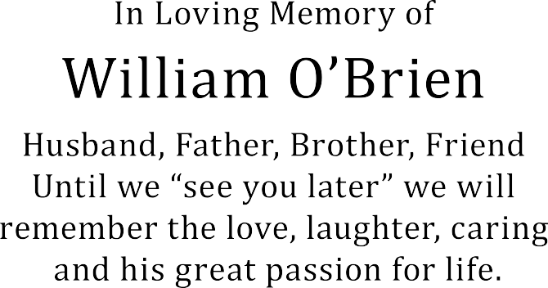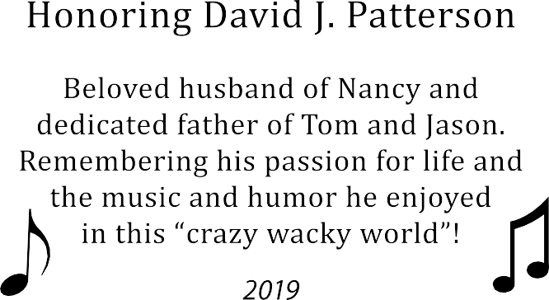

Text ( like the amount shown in the above example) can be enlarged to help fill space, depending upon the initial amount of text.
Text in example above is at minimum letter height.
Simple clip art can be added but can take up to 2-3 lines space

Commons Tree Plaque Wording
Please submit your plaque text in the exact format you would like to see on your plaque.
Capital letters/upper and lower case and any special spacing needs to be reflected in your submission.

Contact Name:
38 Characters per line maximum, 7 lines maximum

1
2
3
4
5
6
7
QR Code Info (Office Use - this information about your tree will be added by the City of Excelsior):
1
2

Plaque example and helpful information:

Plaques are 6” x 4”
Text shown is at minimum letter height.
NOTE: Additional information about your honoree(s) can be accessed by scanning the plaque’s QR code with a smartphone. Please let us know if you would like to include more information.

