Adopt-A-Tree or Seat in The Commons
Celebrate an occasion or remember someone special by adopting a tree or a seat in The Commons Park

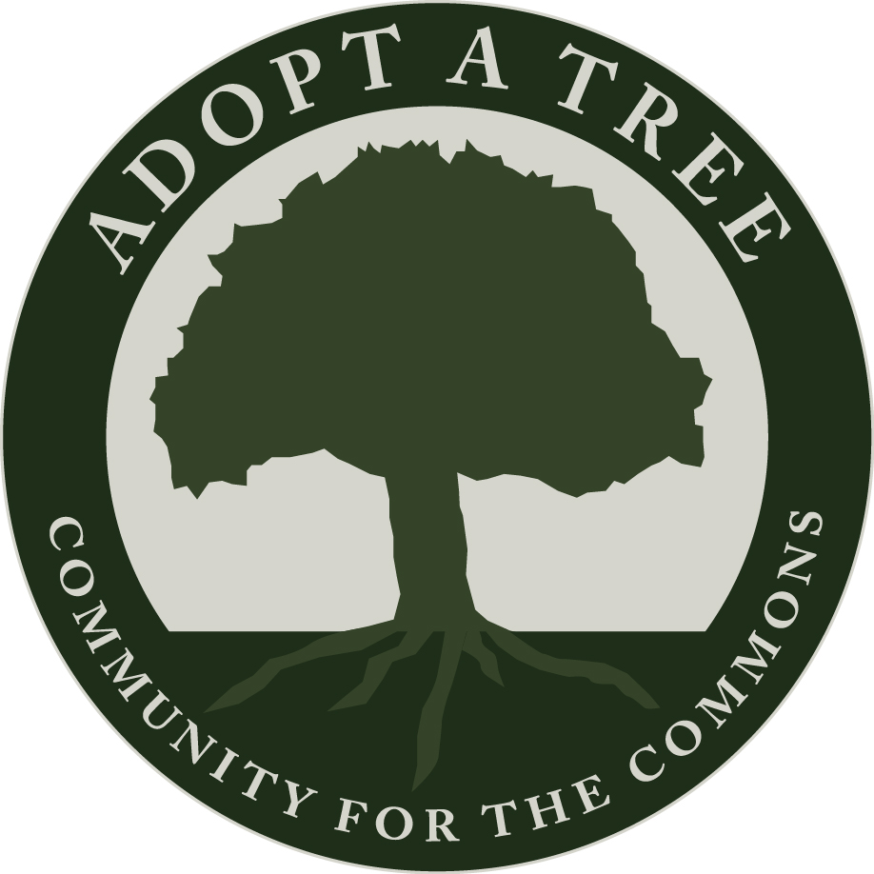
ADOPT-A-TREE
The trees of Excelsior’s Commons are the oldest amenity in the park; many are over 100 years old. By adopting a tree you can give it the care that it needs now, while supporting an endowment fund for the long-term care of our beautiful park landscape.
The City of Excelsior will continue to provide a baseline level of care and adopted trees will receive elevated care from a certified arborist including pruning, soil care and mulch.
Adopted trees will be marked with scannable ID tags, linked to honoree information as well as facts about the tree itself.
Tree Adoption Options:
Plant a New Tree $3,000*
Adopt a Historic Tree $6,000*

*Donations may be spread over 3 years. Matching funds may be available through our program sponsors. Call to learn more.

ADOPT-A-SEAT
Your gift of park furniture will offer comfort for visitors as they enjoy a day at the park. Seats will be marked with a plaque to highlight your event or honoree.
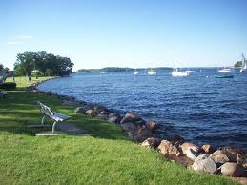

The Excelsior Park Commission is working on a plan for future seat options. This plan is expected to be complete by Spring of 2019.

The Commons Adoption Programs are offered by the City of Excelsior and administered by Community for The Commons, a 501 (c)(3) nonprofit park conservancy. Donations are tax-deductible to the fullest extent of the law. Contact us at Adoptions@communityforthecommons.org or 952-250-4670.

The Commons Adopt-A-Tree & Seat Program Application
To adopt an item in The Commons park, please contact us at 952-250-4670 or via email at Adoptions@communityforthecommons.org. We will work with you to select an available item for adoption as well as a location for its placement. Once you have selected your item and location, please complete this adoption form to submit along with your initial payment.

Applicant Contact Information: (please keep us informed of any changes during your adoption term)
Name: | Phone:
Street: | Email:
City, State, Zip: | Adopted Item Inventory # and details (admin use):
Proposed Honoree Information for ID tag or Plaque: (Please see attached Policy for allowable wording)
Line 1:
Line 2:
Line 3:
Donors will be recognized by name via ID Tag, Plaque, Electronic Newsletter, and via other forms of communication. You may choose to keep your name private by checking this box:

Adoption Preference: Please select adoption preference. The term for a tree is 20 years; for seats it is 10.
- New Tree
- Historic Tree

- Bench
Seat Options Available Soon!
- Picnic Table
Payment Options (Choose 1):

- Option 1: Lump sum payment

- Option 2: 3 equal installments (we will send you an annual reminder)

I am including a check in the amount of $___________________________________
(Your donation is tax deductible to the fullest extent of the law. You will receive a gift acknowledgment letter to use with your tax return)

I have read the attached Donation Policy provisions and agree to abide by the terms and limitations. I also understand that a portion of my donation may be directed to a designated Endowment Fund, the income from which will be used for the long-term care of the trees and furniture that are enrolled in these programs:

Signature of Donor ___________________________________________ Date: ________________________

Please return completed form along with your donation (or installment) to:
Community for The Commons, P.O. Box 333, Excelsior, MN 55331
Adopt-A-Tree and Adopt-A-Seat Policy Provisions, City of Excelsior

- Term
The term of adoption for seating is 10 years and for trees is 20 years, during which the City will maintain identifying markers, tags and plaques. If, during the term of adoption, the item dies or must be removed or relocated, the donor will be located using contact information on file, and offered a replacement item and related identification. If no suitable location for the adopted item is available, another adopted item will be offered in its place. The City reserves the right to remove and replace or relocate adopted items at its discretion. Donors are responsible for keeping all contact information up to date with the Program Administrator.
- Re-Adoption
After the adoption period ends, the City may make the memorial item available for re-adoption and will attempt to contact the donor using the contact information on file. At that time, the original donor can express their desire to re-adopt. If a donor is unreachable, updated contact information was not provided, or the donor did not signal their desire to re-adopt by contacting the City, the City may allow for a new donor to adopt the item. The original donor plaque and ID Tag that is in good condition may remain intact unless the bench or tree is replaced due to its condition or unless other changes are necessary. Donors are responsible for keeping all contact information up to date with the Program Administrator.
- Allowable Wording on Plaque and ID Tag and Other Limitations
- No lifespan (birth and death) dates are allowable on plaques or ID tags.
- Profanity, obscenities, hate speech, symbols, or inappropriate references are prohibited.
- Plaques and ID tags written in languages other than English are welcomed. Adoptee must provide correct translation into English for approval of wording.
- The City reserves the right to terminate, with no refund, any adoption where the donor or the honoree’s reputation falls into disrepute due to an act of turpitude.
- No items may be placed by donors on or near the adopted item including flowers, trinkets, ashes or other memorabilia. Violators risk revocation of adoption without refund.
- Plaques and ID tags symbolize the donation and do not entitle the donor to ownership of the donated element.
- No restrictions may be placed by donor regarding the use of the adopted item.
The Commons Adoption Programs are offered by the City of Excelsior and administered by Community for The Commons, a 501 (c)(3) nonprofit park conservancy. Donations are tax-deductible to the fullest extent of the law. Contact us at Adoptions@communityforthecommons.org or 952-250-4670.

